SPaG

Word classes
Sentence structure
‘Zero Tolerance’ spellings.

English
Writing
- The Dam
Persuasive Letter
- Mr Bumble
Character and Setting Description

Reading
Read a range of texts
Guided reading

.

French
Actions

Mathematics
Number and place value
Written methods for four operations
Arithmetic

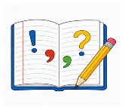

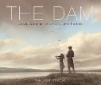

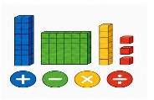
Science

Light and Shadow


P.E
Fitness
6D- Monday/Thursday
6MW- Thursday/Friday
6G Wednesday/Friday


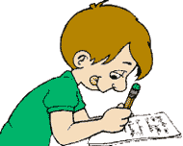
Art and Design Technology
Artist Study- Romero Britto
Architecture


Music
Charanga- Happy

History
WW2
-Evacuation
-The Blitz
-Rationing
-Anne Frank

Equipment
- Water bottle
- Reading book
- Pencil Case
- Necessary medication (handed to class teacher)

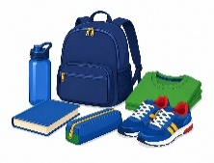
RE
Hinduism

Year 6 Curriculum Plan
Term 1 - 2026



P.S.H.E.

Being Me in My World

Core School Value
Care and Kindness



Key Dates
- 9th September -Meet the Teacher at 3:30-4:00pm
- 7th October-Nasal Flu Vaccine
- 15th October- Harvest Bread making
- 23rd October -Last day of term
- 26th October- 30th November- Half Term
- 3rd and 5th November -Parents Evenings

Dear Parents/Carers,
A very warm welcome to Year 6! The children have already made a brilliant start and we are really looking forward to the exciting year ahead.
Year 6 is a busy but rewarding year. The children will continue to grow in confidence and independence, while enjoying plenty of opportunities to take on responsibilities and be positive role models for our younger pupils.
We look forward to working with you and celebrating all the children’s achievements throughout the year.
The Year 6 Team

