

Art and Design Technology
William Morris –
Printing

English

- Character and
setting
description
- Formal information text
- Poetry
- Guided Reading

.

Music

Livin’ on a Prayer (Charanga)

Science

Properties of Materials

Computing

Microsoft Publisher

History
Trade and Bristol

Mathematics
- Place value and the number system
- Written methods for addition and subtraction
- Multiplication tables up to 12x12
- Practical problem solving

Year 5 Curriculum Plan
Term 1
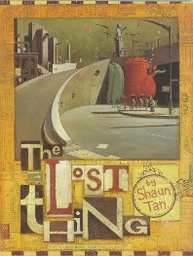

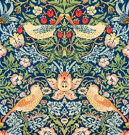

P.E

Tag rugby



Geography
None this term

Religious Education
Who can inspire us?

French
Recap of vocabulary – days/ months/ colours/ numbers/ animals




Core School Value
Care and Kindness
P.S.H.E.

Being me in my world



Key Dates
- PE: Wednesday and Thursday 5TW
- PE: Tuesday and Thursday 5S/5BG
- Meet the teacher sessions 3:30-4:00 8th September
- Individual photos 23rd and 24th September
- Flu nasal spray 7th October
- Last day of term 23rd October
- Half term 26th-30th October
- Parents Evenings 3rd and 5th November

Dear Parents/Carers,

We hope you had a wonderful summer break and have settled back into the school routine comfortably. The children have adapted to their Year 5 classrooms and the new academic year extremely well and we are all very proud of their conduct. We have a rich learning journey planned for this term, centred around the text The Lost Thing by Shaun Tan.
It was lovely to see many of you at our Meet the Teacher afternoon. If you were unable to attend, the curriculum overview for the year can be found on the school website.
-The Year 5 Team

