





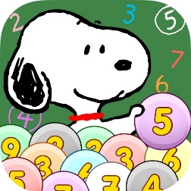







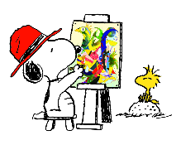


Welcome to Year 4! We hope you had a restful summer break and we are looking forward to a wonderful year of learning.

As usual at the start of any year, there will be a lot of new information being given. Please continue to check for any updates or other information regularly.
If you have any general queries or need to report absences, please email the school office.

We have PE on Friday afternoons and swimming on Wednesdays so please make sure your child is dressed appropriately.

Key Dates:
Meet the Teacher Session (in classroom)- Wednesday 9th September 3.30 - 4pm Parents Evenings 3rd and 5th November
Swimming starts – Wednesday 16th September
Nasal Flu Vaccine -Wednesday 7th October
Last day of Term 1 - Friday 23rd October
Half Term - Monday 26th - Friday 30th October
First day of Term 2 - Monday 2nd November

We are looking forward to an exciting year ahead filled with new learning and discoveries!

Year 4 Team.

Music
Peter and the Wolf
Mamma Mia
Rhythm games

Mamma Mia

P.S.H.E.
Care and Kindness
New beginnings

Religious Education
How do people express their beliefs and identities?
Mathematics
Place value
Written methods for
addition, subtraction,
multiplication and division
Data handling
Times tables
Geography
Not taught this term.
Science

States of
matter

Games / P.E
Invasion Games
Throwing
and catching skills
Swimming

English
Reading
A selection of poems and short texts will
be discussed during guided reading.
Sharing and discussing favourite stories.
Daily story time – class choice.

Writing
Non-chronological report
The Barnabus project
Poetry – On the Ning Nang Nong by Spike Milligan
ULS Spelling
ULS Handwriting

.

History
Romans
French

My family
and greetings

Computing
Document Editing & E-Safety
Document editing
Internet research
E-safety sessions.

Art and Design Technology
Mosaics
Gaudi

Core School Value
Care and Kindness
Year 4 Curriculum Plan
Term 1

