
French
Phonics and
‘In the classroom’
Computing
Touch-typing
E-safety

Mathematics
Number and place value
Addition and subtraction
Number fluency – number bonds to and within 10, 20, 50 and 100; doubles facts

English
Writing
Oracy
Narrative
Setting description

Handwriting
Letter formation and joined up handwriting skills

Reading
Guided reading in class
Reading at home every day

.

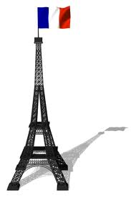
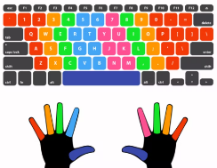

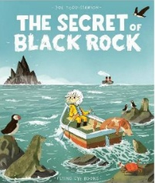


Science
Animals including
humans: Healthy
eating

P.E

Football
Dance

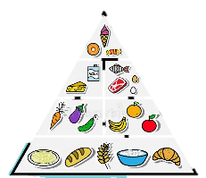
Art and Design Technology
Mark making
Self-portraits

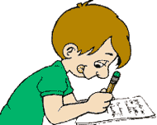


Year 3 Curriculum Plan
Term 1
History
The Stone
Age

Geography
None this term

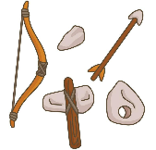
P.S.H.E.

Jigsaw - Being Me in my World


Religious Education
Belonging - What is important to me?





Core School Value
Care and Kindness
Music
Appraising, understanding
and performing music (singing)




Look out for:
- Nasal Flu Vaccine – 7th October
- Windmill Hill City Farm trip (look out for a letter in the coming few weeks) – 13th and 14th October
- Parents evenings 3rd and 5th November
- Last day of Term 1: 23rd October
- First day of Term 2: 2nd November
Dear Parents,
It has been lovely to welcome your children into Year 3 as well as to meet many of you during our Meet the Teacher session.
Your child will have already brought home a reading record and a reading book. Initially this is likely to be the same book band that they were reading in Year 2. We recommend that you listen to your child read every day. Please remember to record this reading in your child’s reading record.
We are very much looking forward to working with you and getting to know your children over the coming year.
The Year 3 Team

