Art and Design Technology
What are bridges?
How do we build bridges?
Designing and building our own bridges

History
Who was Isambard Kingdom Brunel? What did he build?
How did Brunel’s projects change the city of Bristol?

English
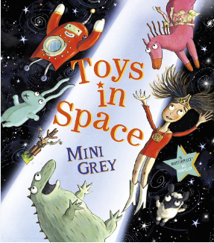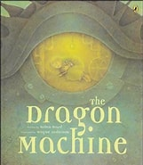
Say, write and punctuate simple sentences using the joining words and, but, when.
Secure the use of full stops, capital letters.
Discuss and plan what to write about, innovating a known story, generating and developing vocabulary and ideas.

.

Mathematics: Place Value
Recognise tens and ones and
Partition numbers to 100
Flexibly partition numbers to 100
Count in 2s, 5s Count in 10s
Count in 3s
Bonds to 10/20/100
Fact families - addition and subtraction bonds within 20


P.E
Working on co-ordination, balance and
Fitness.
Yoga lessons

Computing
What is information technology?
Information Technology in the world and its uses

Science:
Materials and their uses
What are different everyday materials and where are they used?
How suitable are different materials for various uses?
Famous Scientist: Charles Macintosh

Year 2 Curriculum Plan
Term 1
Music
Learning "Hands, Feet, Heart", a song celebrating South African music. Dimensions of music (pulse, rhythm, pitch etc), singing and playing instruments

R.E
Harvest festival in UK and around the world.
Jewish Festival of Sukkot, The Festival of trees, The story of Holi and the celebration



P.S.H.E. Being Me in My World
I can recognise when I feel worried and know who to ask for help. I know how to help myself and others feel like we belong. I help make my class a safe and fair place.


Core School Value
Care and Kindness

Key Dates
P.E days are Monday indoor & Friday outdoor. Please can children come dressed in their P.E kits on those days.
Friday 25th September First spelling check
Wed 14th October Dragon Reading Adventure
9th September -Meet the Teacher at 3:30-4:00pm
7th October-Nasal Flu Vaccine
23rd October -Last day of Term 1
26th October- 30th November- Half Term
3rd and 5th November -Parents Evenings

Welcome to Year 2.
We hope your children have had an enjoyable start to the year. By now your child should have come home with a new reading book. Children should be reading at home at least 3 times a week.Please remind your child to change their books.
Current research is also highlighting the importance of reading to your child in order to increase their vocabulary, comprehension and love of reading. Please try and read a story to your child as often as possible.

A little plea. In order to fund some of the curricular activities we have planned to do with the children this year, we would appreciate if you could you send in a £5 contribution. The money will be used to bring our topics to life for example food tasting and additional art activities. Please can we also ask for a box of tissues for the cold and flu season as we rapidly go through them.

