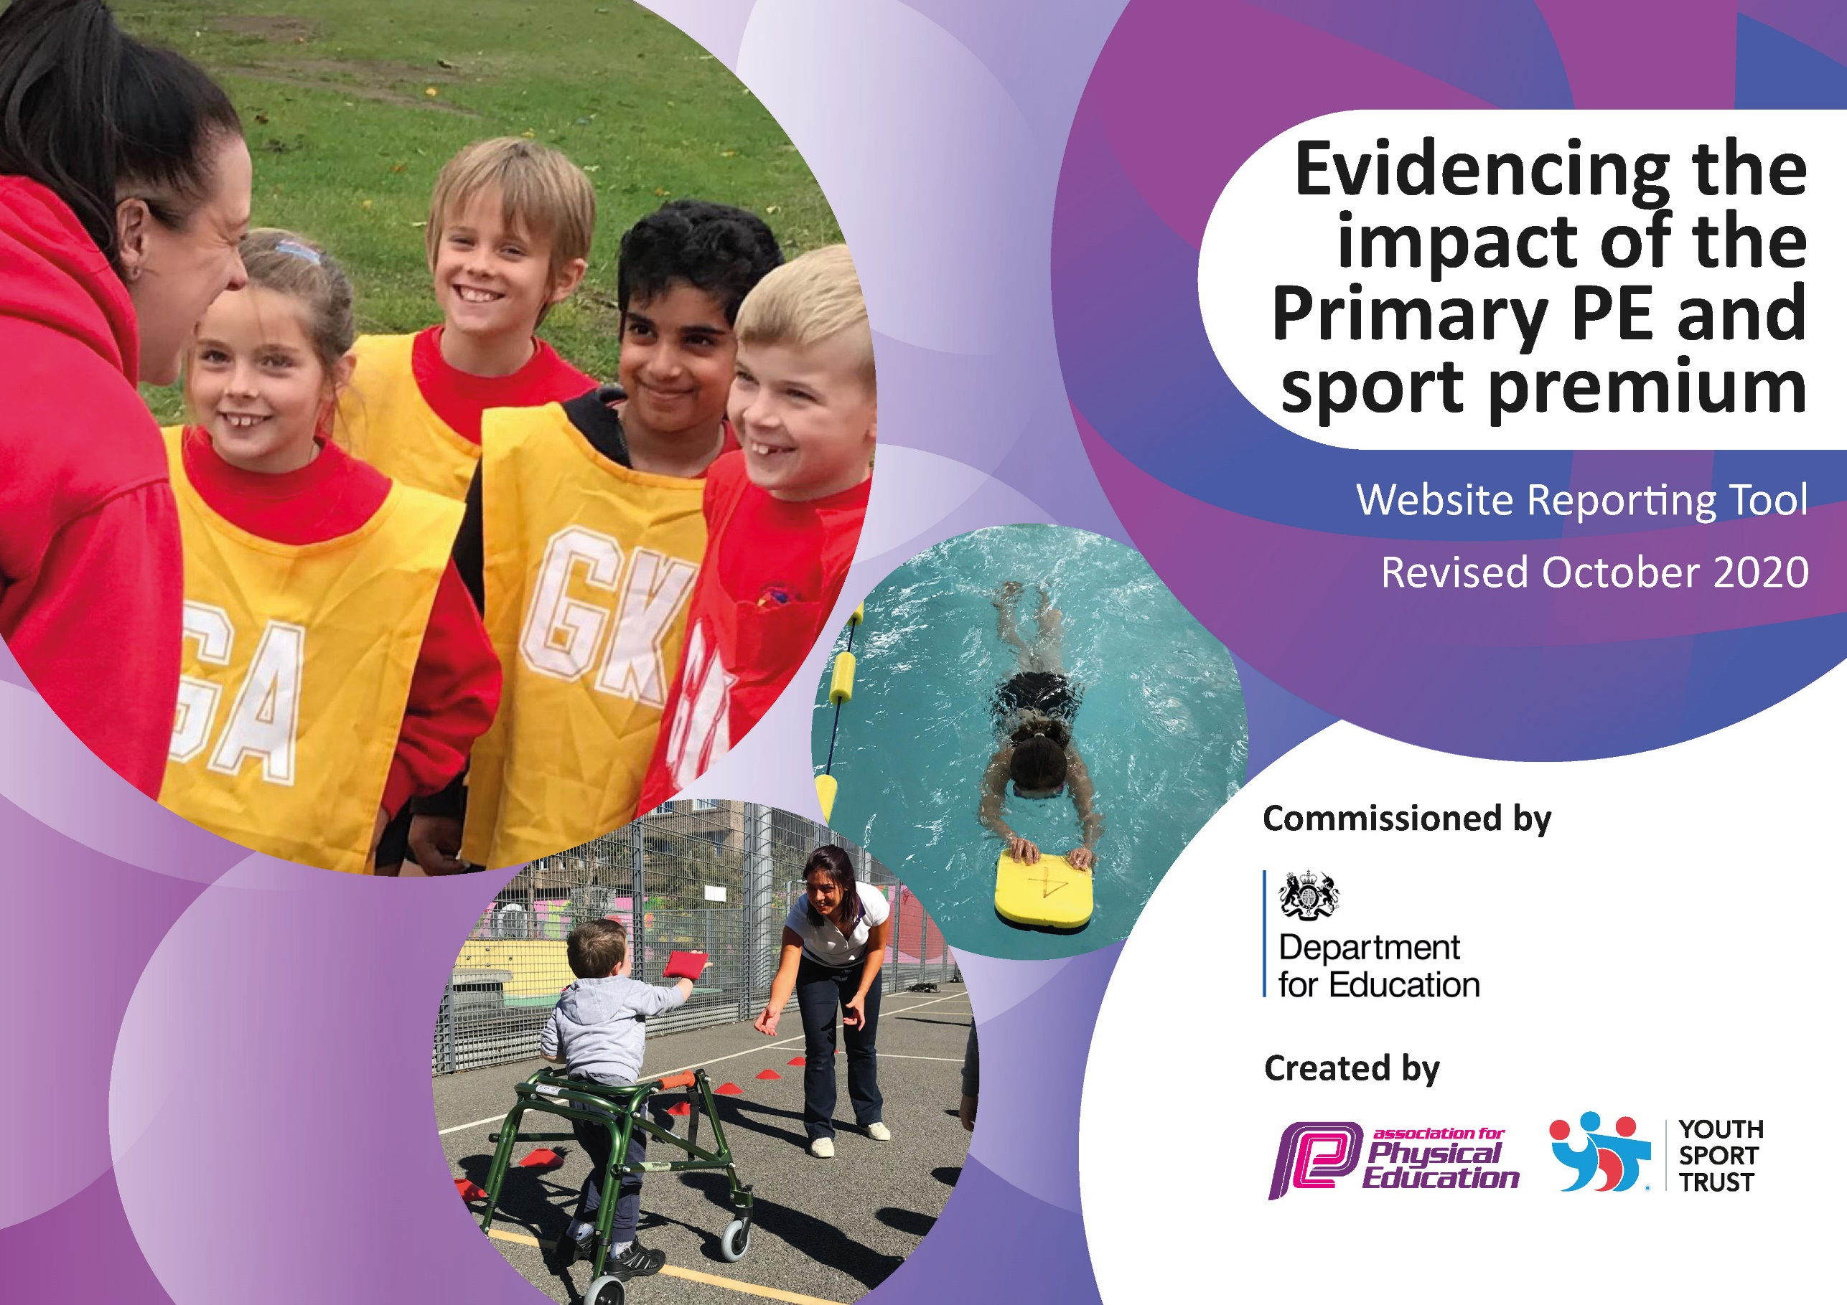
High Down Infant School
2025 - 26
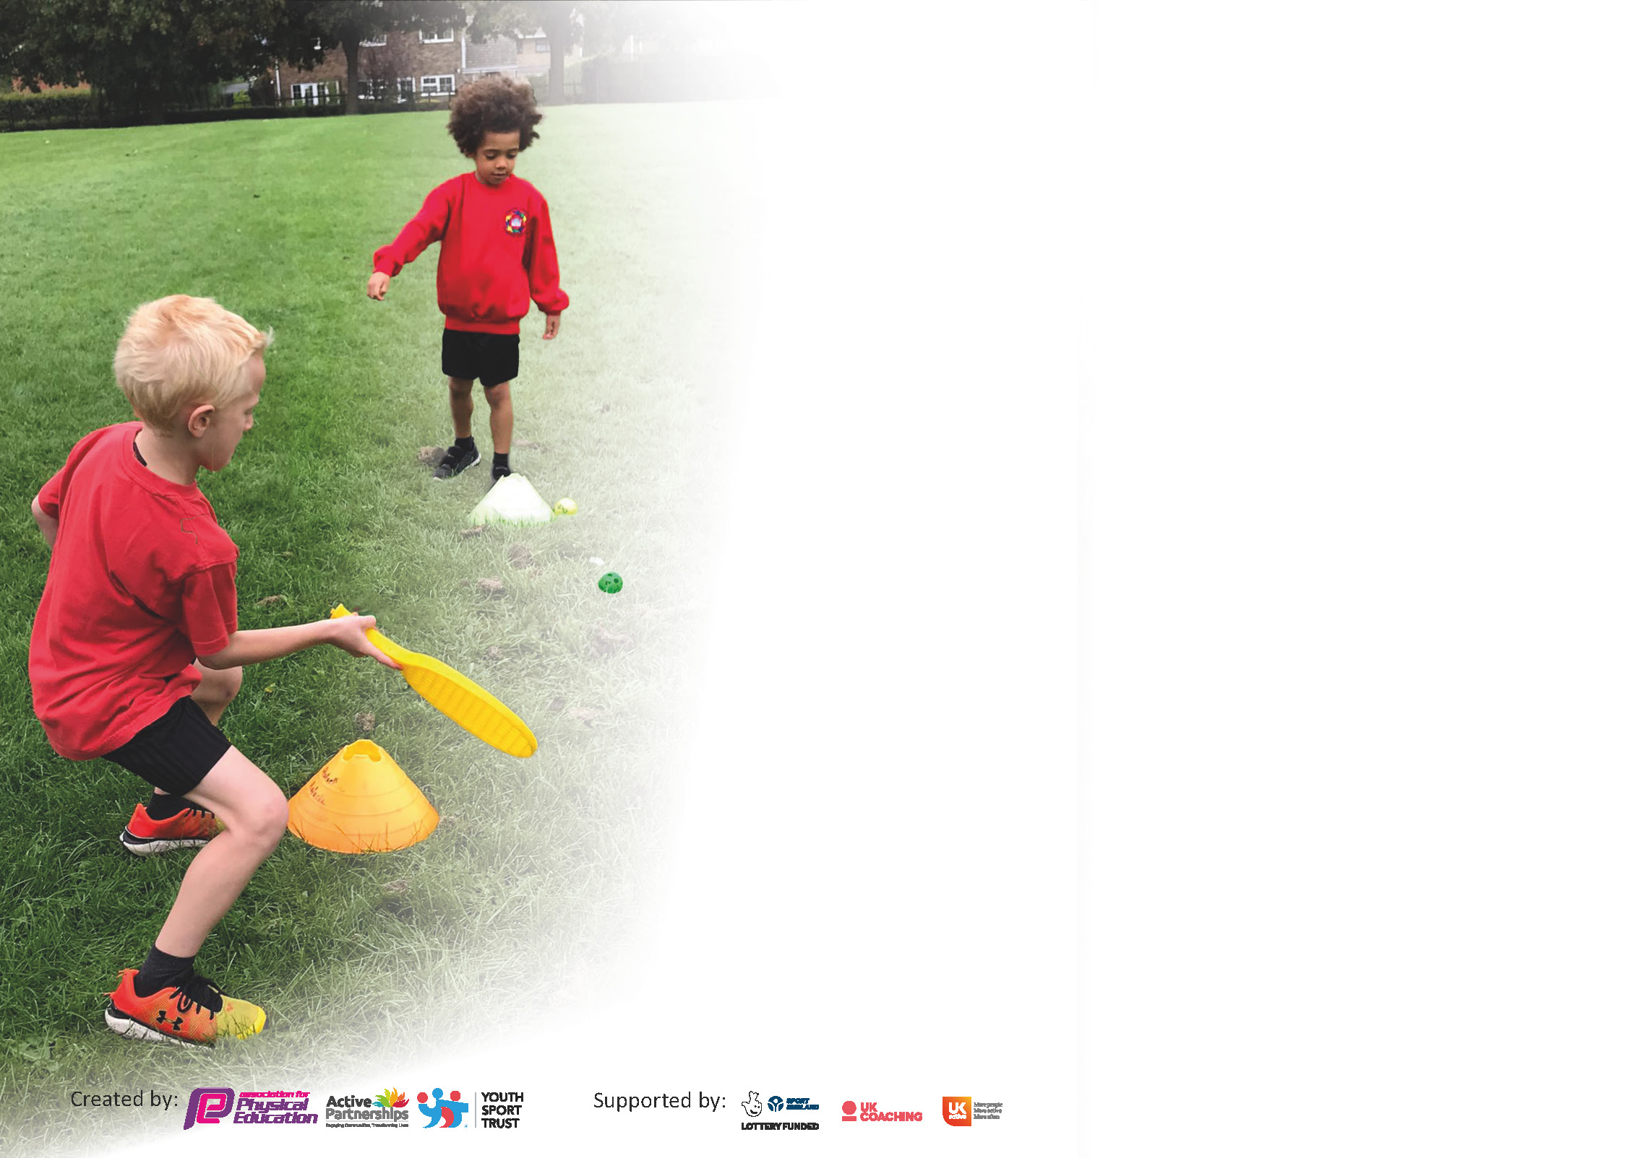

It is important that your grant is used effectively and based on school need. The Education Inspection Framework (Ofsted 2019 p64) makes clear there will be a focus on ‘whether leaders and those responsible for governors all understand their respective roles and perform these in a way that enhances the effectiveness of the school’.

Under the Quality of Education criteria (p41) inspectors consider the extent to which schools can articulate their curriculum (INTENT), construct their curriculum (IMPLEMENTATION) and demonstrate the outcomes which result (IMPACT).

To assist schools with common transferable language this template has been developed to utilise the same three headings which should make your plans easily transferable between working documents.

Schools must use the funding to make additional and sustainable improvements to the quality of Physical Education, School Sport and Physical Activity (PESSPA) they offer. This means that you should use
the Primary PE and sport premium to:

- Develop or add to the PESSPA activities that your school already offer
- Build capacity and capability within the school to ensure that improvements made now will benefit pupils joining the school in future years

Please visit gov.uk for the revised DfE guidance including the 5 key indicators across which schools should demonstrate an improvement. This document will help you to review your
provision and to report your spend. DfE encourages schools to use this template as an effective way of meeting the reporting requirements of the Primary PE and sport premium.

We recommend you start by reflecting on the impact of current provision and reviewing the previous spend.

Schools are required to publish details of how they spend this funding as well as on the impact it has on pupils’ PE and sport participation and attainment by the end of the summer term at the latest.
We recommend regularly updating the table and publishing it on your website throughout the year. This evidences your ongoing self-evaluation of how you are using the funding to secure maximum, sustainable impact. Final copy must
be posted on your website by the end of the academic year. To see an example of how to complete the table please click HERE.
Created by: Supported by:

Support for review and reflection - considering the 5 key indicators from DfE, what development needs are a priority for your setting and your pupils now and why? Use the space below to reflect on previous spend and key achievements and areas for development.

Key achievements to date until July 2025 | Areas for further improvement and baseline evidence of need:
- Lead SMSA encouraging and co-coordinating outdoor play and team games for lunchtime.  - We have continued to establish strong links with local clubs including Gym Stars, Karate, Street Dance and North Somerset PE Association.  - We have taken on a new club, Gymstars  - We are able to offer a bursary for pupil premium children to participate in these clubs.  - We have offered every year group a professional dance session linked to their learning.  - P.E board effectively being used in the hall to enhance teaching.  - New equipment purchased to support active fitness at play times.  - New equipment purchased to support delivery of Real P.E.  - Every year group had the opportunity to take part in sessions run by North Somseret PE association - Speedstacking KS1, Quadkids KS1/R, Molkky KS1, Boccia/Kurling KS1  - Virtual Leagues took place and results shared in the newsletter.  - Inter school sports festival attended with other local schools.  - Sports week was held in July 2025, enabling children to take part in a wide range of physical activities e.g. cycling, golf, orienteering. Parents attended across the whole school. | - Continue to provide children with the opportunity to take part in competitive sports in inter and intra school competitions.  - Continue to focus on active lunchtimes with use of sports equipment.  - Sports Leaders to be trained from the Junior School to provide additional support in the Infants.  - Continue to support lead SMSA.  - Liaise with the Juniors Head of PE about training sports leaders for playtime.  - Continue to monitor and review the impact of Real P.E.  - Update the school noticeboard/ newsletter to promote sport at High Down Schools  - Further developing virtual leagues across KS1 to increase competition and to beat class personal best.  - Investigate additional Inter school competitions targeting PP children in order to support the development of core skills.  - Dance workshops to be provided across KS1  - North Somerset Association sessions to be booked for the whole school.  - Fox Cycling opportunities for children to improve their balance and learn to ride a bike.

TOTAL ALLOCATION: £17,280
Action Plan and Budget Tracking
Capture your intended annual spend against the 5 key indicators. Clarify the success criteria and evidence of impact that you intend to measure to evaluate for pupils today and for the future.

Academic Year: 2025/26 | Total fund allocated: £17,280 | Date Updated: October 2025
Key indicator 1: The engagement of all pupils in regular physical activity – Chief Medical Officers guidelines recommend that primary school pupils undertake at least 30 minutes of physical activity a day in school |  |  |  | Percentage of total allocation:
 |  |  |  | £13,287
Intent | Implementation |  | Impact | 77%
Your school focus should be clear what you want the pupils to know and be able to do and about  what they need to learn and to  consolidate through practice: | Make sure your actions to achieve are linked to your intentions: | Funding allocated: | Evidence of impact: what do pupils now know and what can they now do? What has changed? | Sustainability and suggested next steps:
• Year 5 and Year 6 Sports Leaders/ buddies to promote positive play and support children during lunchtimes  - Regular opportunities for outdoor activities in all year groups in line with our school risk assessment  - Staff complete audit (supply costs) and then develop a programme of ongoing replacement and enrichment of resources to support physical activity and the development of sports skills (e.g. skipping ropes, basketball hoops) to increase the engagement of all children in physical activity.  - To continue to support the Lead SMSA to arrange the daily PEP activities and support/train the additional PEP SMSAs  - To provide additional lunchtime supervisors (SMSAs) to focus on providing daily Positively Energetic Play (PEP) opportunities for the children  - Dance workshops  - Increase core balance and cycling skills across the infants | Mentoring to enable positive play and support offered to vulnerable and disadvantaged pupils  Co-ordinators to review curriculum opportunities to undertake daily physical activity.  Children engage with a wider range of physical activity and develop their skills, including at break and lunchtimes.  Promote sports games and equipment during lunch times.  Lead PEP activities with the children to encourage increased daily physical activities.  Primary workshops for school booked to provide high quality experiences for all children  Circus skills  Skipping workshop  Chinese Dragon dance  Offer all children the opportunity to increase core balance and learn to cycle | £0  £0  £967  £1000  £9000  £1200  £1,120
Key indicator 2: The profile of PESSPA being raised across the school as a tool for whole school improvement |  |  |  | Percentage of total allocation:
 |  |  |  | £1318
Intent | Implementation |  | Impact | 8%
Your school focus should be clear what you want the pupils to know and be able to do and about  what they need to learn and to  consolidate through practice: | Make sure your actions to achieve are linked to your intentions: | Funding allocated: | Evidence of impact: what do pupils now know and what can they now do? What has changed? | Sustainability and suggested next steps:
- Raise the profile of a range of physical activities and the benefits thereof, motivating the children to become more active.  - Raise the profile of a range of Sports and motivate the children  - NSSPEA staff will update co-ordinators, share best practice and signpost new opportunities. Co-ordinators will then disseminate to staff  - Enhance children’s understanding of the determination and resilience required in learning new skills. | Invite Inspirational adults to lead whole-school assemblies to raise the profile of different sports. Children to feel inspired and motivated to engage with a wider range of sports.  ‘Sport’s board’ dedicated to promoting sport across the school. Raised profile of PE and sport across the school and increase knowledge of local sports clubs and facilities. Sporting assemblies.  Co-ordinators to attend network training/ watch recordings and be responsible for disseminating information shared. Also enables us to access a range of activities for Sports Week.  Include famous sporting figures from the past as role models in other school activities e.g Jesse Owens, Wilma Rudolph in Black History Month | £0  £0  £1,318  (membership)  £0

Key indicator 3: Increased confidence, knowledge and skills of all staff in teaching PE and sport |  |  |  | Percentage of total allocation:
 |  |  |  | £1295
Intent | Implementation |  | Impact | 7%
Your school focus should be clear | Make sure your actions to | Funding | Evidence of impact: what do | Sustainability and suggested
what you want the pupils to know | achieve are linked to your | allocated: | pupils now know and what | next steps:
and be able to do and about | intentions: |  | can they now do? What has
what they need to learn and to |  |  | changed?:
consolidate through practice:
- Further CPD for staff in teaching gymnastics with apparatus as needs are identified.  - Renewal of Real P.E. subscription  - Support SMSA CPD. This is ongoing, due to lunchtime staff turnover.  - Supply costs to release staff for high quality training and for co-ordinator monitoring of lessons | Staff survey to identify needs. Other needs will be identified from monitoring.  New SOW is embedded, leading to all children receiving high quality P.E. lessons, developing new skills and enhancing physical fitness.  SMSAs are confident to provide active sessions at lunchtime  Staff undertake quality CPD opportunities. Co-ordinators observe class lessons and provide developmental feedback to continue to improve practice across the school. Work with pupil voice groups. | £0 part of NSSPEA  membership  £695  £200  £400
Key indicator 4: Broader experience of a range of sports and activities offered to all pupils |  |  |  | Percentage of total allocation:
 |  |  |  | £1000
Intent | Implementation |  | Impact | 6%
Your school focus should be clear | Make sure your actions to | Funding | Evidence of impact: what do | Sustainability and suggested
what you want the pupils to know | achieve are linked to your | allocated: | pupils now know and what | next steps:
and be able to do and about | intentions: |  | can they now do? What has
what they need to learn and to |  |  | changed?
consolidate through practice:
- Sports Week in July 2026 To increase the range of different sporting activities that the children are offered  - To broaden range of school clubs  - Review resources that can be loaned from NSSPEA to enhance school offer for children | All children to take part in a week long intra- school competition. Children to participate in a wide range of sports activities led by a variety of sporting groups including yoga, archery, dance, golf, orienteering, quad kids, virtual leagues etc  Review existing clubs and take up  Commence a new club.  Children access a broader range of sports | £1000  £0  £0  As part of NSSPEA membership

Key indicator 5: Increased participation in competitive sport |  |  |  | Percentage of total allocation:
 |  |  |  | £380
Intent | Implementation |  | Impact | 2%
Your school focus should be clear | Make sure your actions to | Funding | Evidence of impact: what do | Sustainability and suggested
what you want the pupils to know | achieve are linked to your | allocated: | pupils now know and what | next steps:
and be able to do and about | intentions: |  | can they now do? What has
what they need to learn and to |  |  | changed?:
consolidate through practice:
To participate in inter school competition run by NSSPEA  Compete in virtual leagues | Provide a competitive opportunity for children. Disadvantaged children to have opportunities to represent the school.  Provide minibus to take children to inter school competitions.  Supply costs for teacher and LSA to accompany group to the competition  Children to compete in both inter school competition and externally as part of a virtual league (supported by NSSPEA) Class teacher to win ‘golden whistle’ in celebration assembly termly. | £380  £0

Signed off by
Head Teacher: | Andreya Cowan
Date: | 22/10/25
Subject Leader: | Rebecca Keys/ Ella Biggins
Date: | 22/10/25

